Joshua Tam and Malachi Hamada

Bayesian networks, by definition, “is a probabilistic graphical model that represents a set of random variables and their conditional dependencies via a directed acyclic graph (DAG).”(Wikipedia). An extremely useful invention, the Bayesian networks are useful in just about every aspect of science and mathematics. Yet, it came from one simple theorem; Bayes’ theorem. The theorem questioned that if A implied B under certain probabilities, then what was the probability that B implied A? Yet, he wasn’t what had sparked the invention of Bayesian networks and probability; it was Laplace, who explained that the theorem could be applied toward other fields. Keep in mind that these problems were posed during the 18th century through the middle of the 19th century. AI had not even been created yet! Laplace created the definition of inverse probability, which was the inference of going backwards from observations to parameters.
In the 1980’s the idea of Bayesian networks truly had gone widespread. The discovery of Markov chain Monte Carlo methods can be considered one of the triggering points; Because many of the computational problems were removed, people were finally allowed to give AI an extra boost by using Bayesian probability.
In 1985, Judea Peral created the term “Bayesian networks” to emphasize the subjective nature of input information, Baye’s conditioning, and the distinction between causal and evidential modes of reasoning.(Wikipedia) This gave Bayesian networks it’s own sub-field of study. Today, it remains one of the most intriguing topics, not only because it applies to AI and giving computers ability to infer, but also because Bayesian networks apply to just about every field possible; it is able to store and receive information, creating new information, etc. In my opinion, I believe that Bayesian networks are important in every field, namely mathematics and science. But recently, there have been developments of Bayesian networks in the education field. How can that be?
Bayesian networks largely rely on probability. For example, refer to the chart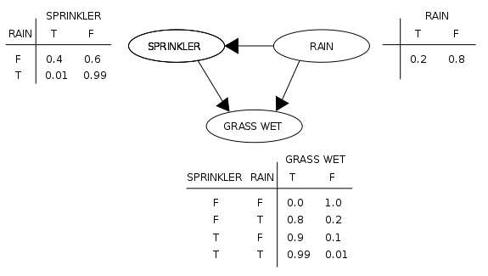As seen in the chart, grass will most likely be wet when there is rain and sprinkler. However, if the sprinkler and rain are false, then the grass will most likely be not wet. By doing this, the networks are allowed to infer that Sprinklers and Rain cause the grass to be wet. Bayesian networks require a lot of probability and graphing. Everything is connected somehow in the Bayesian networks.
In terms of experts in the field, the development of Bayesian networks in the education field is growing very fast. Not quite exponentially, but still fast nonetheless. One expert I believe, is Chan-Lao-Liu, who, in 2008, tried to determine a learner’s personality by certain assessments. Every year, there is the AIED, which is a conference designed for the sole purpose of expanding the use of AI in the education field. Many talk about Bayesian networks for problem solving, human assessments, etc.Understandably so, the AIED is mostly for the academics, because the field of study is still in its infancy, starting in the 1990s, with only 20 years of development. That seems fairly long, but implementing the AI in the field is complicated. Our significant implementation is making an assessment to determine what students lack , try to “connect the dots” on what they don’t get, and determine the underlying concepts that the student has not learned. Then, using the knowledge of what the Student does and doesn’t know, the AI will be able to give feedback on what to do. Reasonably, we may be able to complete middle to high-end version of our project. With a little bit of work, we will have a complete version running with basic understanding of the students.
Here is our daily plan-
Tuesday-Grasp entire concept of Bayesian networks
Wednesday- Re-read Chao Lin Liu’s thesis, and read a few more thesis’s related to Bayesian networks, education in AI
Thursday-Monday: time to program
Tuesday-Thursday; If needed, Malachi program, and Josh Finish powerpoint
Friday-Presentations
In terms of the presentation, the majority will be the logic and reasoning behind the actual program. 5 minutes will be the actual program. The program is the most important. However, the history must be addressed in order to understand what is happening.

